URL: <http://www.sltung.com.tw/tw/pkcase/mypage5.php?mypage_id=184>

Being eager to make everything better and respecting the precious life Dr. Tung works hard and strictly requests all the staff in the clinic to treat all the patients. They can't neglect their duty and make any mistakes.

**Medical services:**

Joint replacement

Cranial facial reconstruction and plastic surgery

Cardio surgical disease treatment

Cardiac catheterization examination and treatment

Assisted reproductive technology

Emergency center

Cardiovascular center

Hyperbaric oxygen therapy center

Women and children health center

Reproductive science center

Advanced health examination center

Hemodialysis center

Cosmetic center

Rehabilitation therapy center

Cancer treatment center

Pet

Ct

High level medical imaging health examination center

Photos

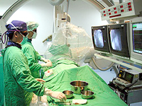 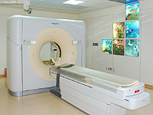 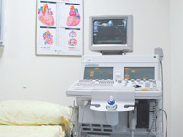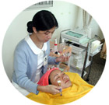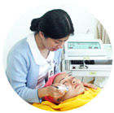 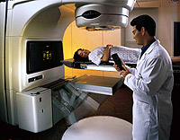

**Doctor’s credentials**

**Doctors in orthopedic**

Hsueh-Ming, Chen

|  |  |
| --- | --- |
| **Shao-Keh, Hsu**  **Kuo-Hsien, Hsieh**  **Doctors in plastic and reconstructive surgery**  Yuh-Chyuang, Tsai  **Zhao-Cyuan, Wu**  **Wen-Zhong, Ye**  **Doctors in cardiology**  Jeng, Wei  **Cing-Wen, Wu**  **Doctors in cardiac catheterization**  Chien-Jung, Chang  **Zheng-Sheng, Lin**  **Kwen-Hsiung Chen**  **Doctor in assisted reproductive technology**  Chen-Lung, Chien    **Contact us:**  No.699, Sec. 1, Jhongci Rd.  Wuci Township,  Taichung Taiwan  Phone: 886-4-26581919 |  |